Virtua Fighter (1993, Arcade), SEGA. GAMEPLAY.

1. Composition
Tangible space | The entire surface of the screen depicts an arena and background scenery.
Intangible space | Visual interface overlays.
Negative Space | None.
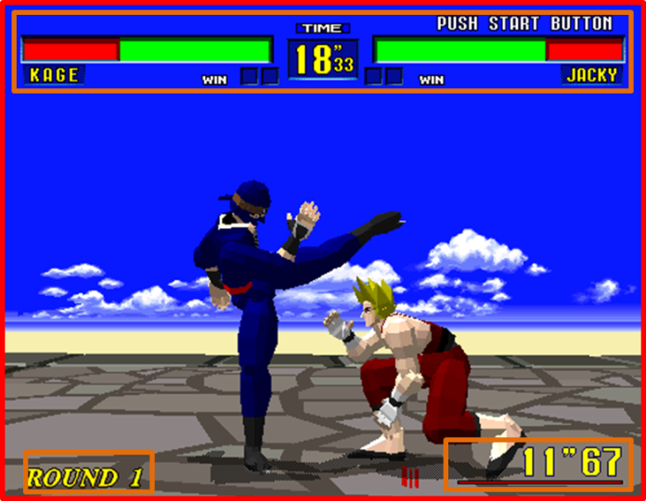
External | Zero ergodic
2. Ocularization

3. Framing mechanisms | Anchor : Intersubjective | Mobility : Connected

4. Plane Analysis
 | Agents | In-game | Off-game
Graphical materials | Real-time polygons | Real-time polygons | Raster backdrop
Projection method | Linear | Linear | Linear
Angle of projection | Horizontal | Overview | Horizontal

Notes :
An exemple of intersubjective framing, which is common to a great number of fighting games. Virtua Fighter was the first high-profile fighting game to simulate the third dimension with polygonal characters. The in-game arena occupies a rather small subset of the tangible space, the bulk of which is made of an off-game static raster backdrop of the sky and horizon line.
