Game title (year, platform), Developer. VISUAL MODE

1. Composition
Tangible space | Elements that belong to the gameplay space.  Ex.: Mario, Tetris blocks, platforms, etc.
Intangible space | Elements that the player doesn’t interact directly with. Ex.: Interface bars and icons.
Negative Space | Decorative or unused portions of the screen that don’t change. Ex.: Window frames, black space.
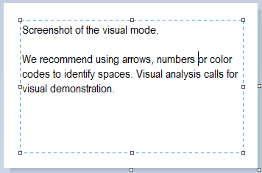
2. Ocularization

3. Framing mechanisms | Anchor : | Mobility :

4. Plane Analysis
 | Agents | In-game | Off-game
Graphical materials
Projection method
Angle of projection

Notes :
In this area you can explain and contextualize the visual mode’s functioning as part of the larger gameplay, or otherwise highlight or explain what facets of the analysis are interesting and why.
The format is meant to be limited. We recommend keeping it short and sweet. It can also be an opportunity to work towards a simplified formulation of the complex conclusions that may result from your analysis.
